Group 5: Aliyyah Jackhan, Mohammad Aadil, Jonathan Chacko
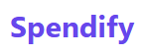

Executive Summary
Spendify is an AI-powered expense analysis and classification system that simplifies receipt-based financial tracking. The system enables users to upload receipts via Discord, processes them through Google Vertex AI's Document OCR, classifies line items using a structured multi-agent ADK pipeline, and stores the results in Firebase. A web dashboard (under development) provides visual summaries and spend forecasting using a regression model.
Originally initiated with LangChain/Ollama for classification, Spendify transitioned to a robust, explainable multi-agent pipeline using Google Cloud's Agent Development Kit (ADK). The backend, built in Flask, integrates seamlessly with the Discord bot and dashboard. Firebase Firestore stores both raw and classified data. Key challenges included LLM inconsistencies, GCP ADK deployment, and cloud authentication. The final product successfully demonstrates an end-to-end automated receipt processing pipeline with future expansion plans for dashboard enhancements and AI chat integration.

Table of Contents
- Introduction
- System Architecture & Technical Design
- Data Flow & Pipeline Implementation
- Testing & Evaluation
- Challenges & Iterative Improvements
- Final Deployment & Demo
- Ethical Considerations
- Conclusion & Future Work
- References

Introduction

Problem Statement
Manual receipt tracking is tedious, error-prone, and lacks intelligence. Users need a seamless way to digitize and analyze spending habits using AI.

Objective
Develop a receipt-to-dashboard pipeline that supports:
- Discord-based receipt upload
- OCR data extraction via Document AI from GCP Vertex AI Platfrom
- LLM/agent-based classification (GCP ADK)
- Spend prediction (regression model)
- Web dashboard for analytics

Milestone Alignment
- M1: Defined system scope, bot integration, API setup, and OCR planning.
- M2: Implemented LLM classification, OCR via Vertex AI, structured Firebase storage.
- M3: Replaced LLM with ADK agent pipeline; built validated end-to-end flow.
- M4: Demonstrated deployed infrastructure, API endpoints, and partial dashboard with testing validation.

System Architecture & Technical Design

Core Components
- Discord Bot: Receives image uploads.
- Flask API: Processes upload, sends images to OCR, returns predictions.
- Vertex AI (OCR): Extracts structured text.
- ADK Pipeline: Multi-agent system for item classification with validation.
- Firebase: Stores raw, structured, and summarized receipt data.

Technologies Used
Flask, Python, Docker, Firebase, Google Cloud (Document AI, Cloud Run), ADK

Infrastructure
- Cloud Run containers for API and ADK
- VM hosting for Discord bot
- CI/CD automation using Dockerfiles and shell scripts

Data Flow & Pipeline Implementation
- Image uploaded via Discord or web form.
- Flask API routes the image to GCP Document AI.
- OCR results sent to ADK classification pipeline.
- ADK agents (Initial Classifier → Grouping Agent → Validation Agent → Finalizer) process and label data.
- Results saved to Firebase under /RAW_DATA, /RECEIPTS, /SUMMARISED_DATA.
- Dashboard fetches data from Firebase for visualization.
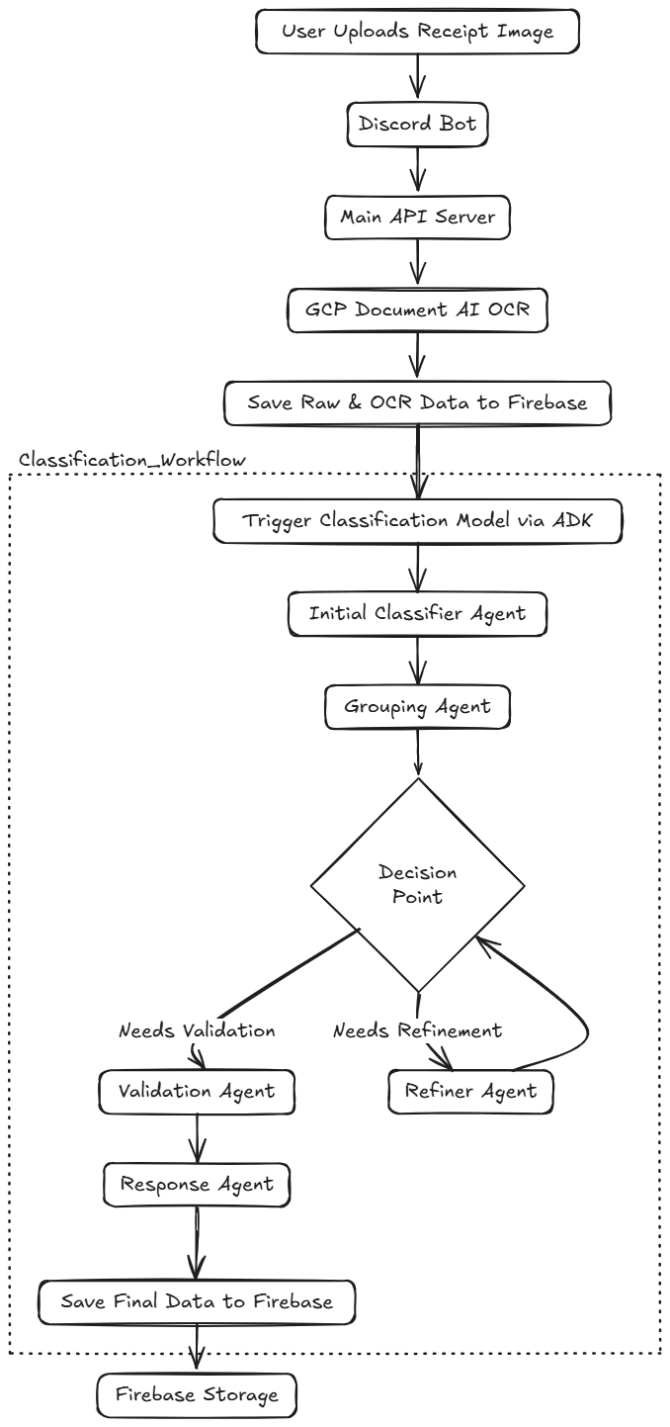

Testing & Evaluation

Testing Conducted
  - Unit Tests: API routes, ADK module, classification functions.
  - UAT: Discord bot tested by multiple users.
  - Manual Tests: End-to-end pipeline validation from upload to classification.
  - Model Validation: Holdout receipts tested for accuracy.

Results
  - Classification accuracy robust for structured receipts.
  - ADK pipeline more stable and explainable than previous LLM-based logic.
  - OCR success rate: ~92% on clean receipt images.
  - Bugs fixed: JSON formatting, Firebase writes, bot edge cases.

Challenges & Iterative Improvements
*Every time Jonathan broke the project
- Challenge of Ollama Agent Inaccuracies
- Challenge faced because Lack of Examples and Documentations for ADK
- Development of the Flask API Logic so that it can be Integrated anywhere with a Secure Dashboard allowing Users from any Source to have a Single Login using Firebase OAuth2.0 Authentication.

Final Deployment & Demo

Deployment Status
- ADK Classification Pipeline: Cloud Run
- Flask API: Cloud Run
- Discord Bot: VM
- Firebase Storage
- Dashboard UI

URLs
- ADK: https://receipt-classifier-32377413295.us-central1.run.app/
- API: https://spendify-api-32377413295.us-central1.run.app/
- Discord Bot: https://discord.com/oauth2/authorize?client_id=1375145987106144297&permissions=8&scope=bot

Demo Summary
Users can upload a receipt via Discord and receive categorized, structured outputs within seconds. Future features will support full dashboard interactivity and spend prediction.
Registration Procedure (can be on a Server):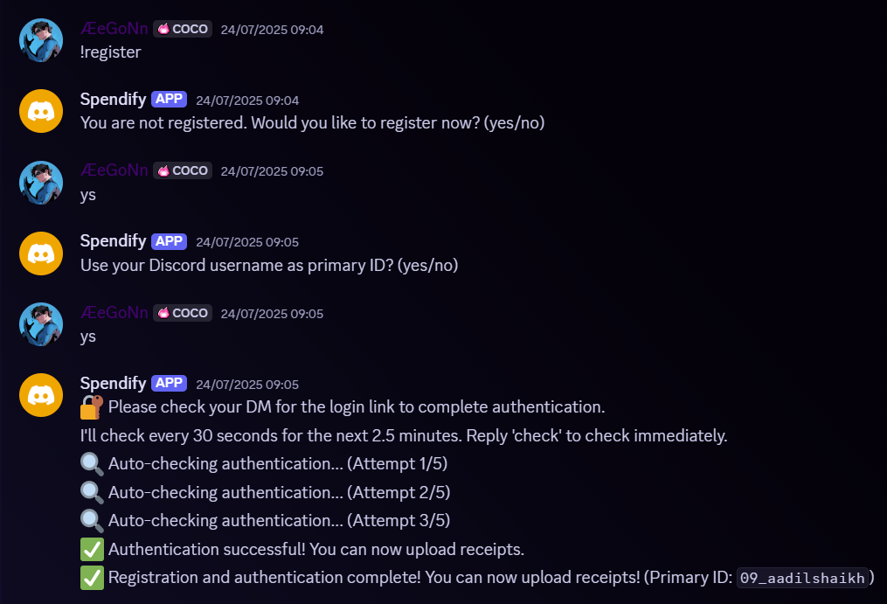
Directly Messaged User the Authentication Link: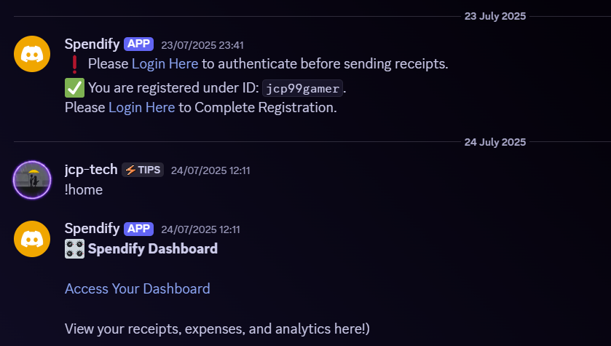
User Upload’s an Image and the Spendify Bot Identifies and Processes it: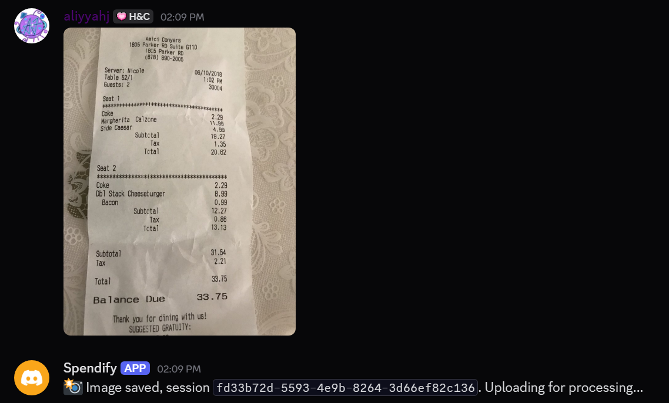
ADK Classification showing the Event’s Pipeline (Sample of what happens in Backend):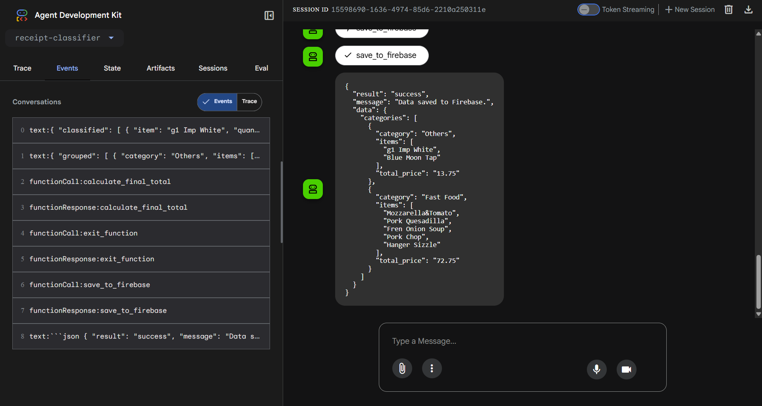
Sample of How the Data Saves on the Firebase Firestore Database: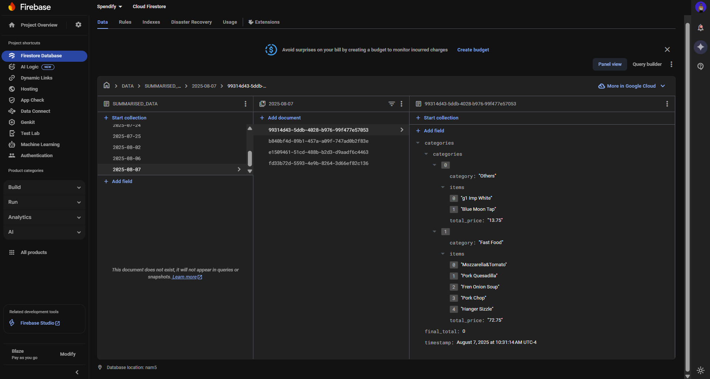
Login Authentication powered by Firebase Authentication with Google: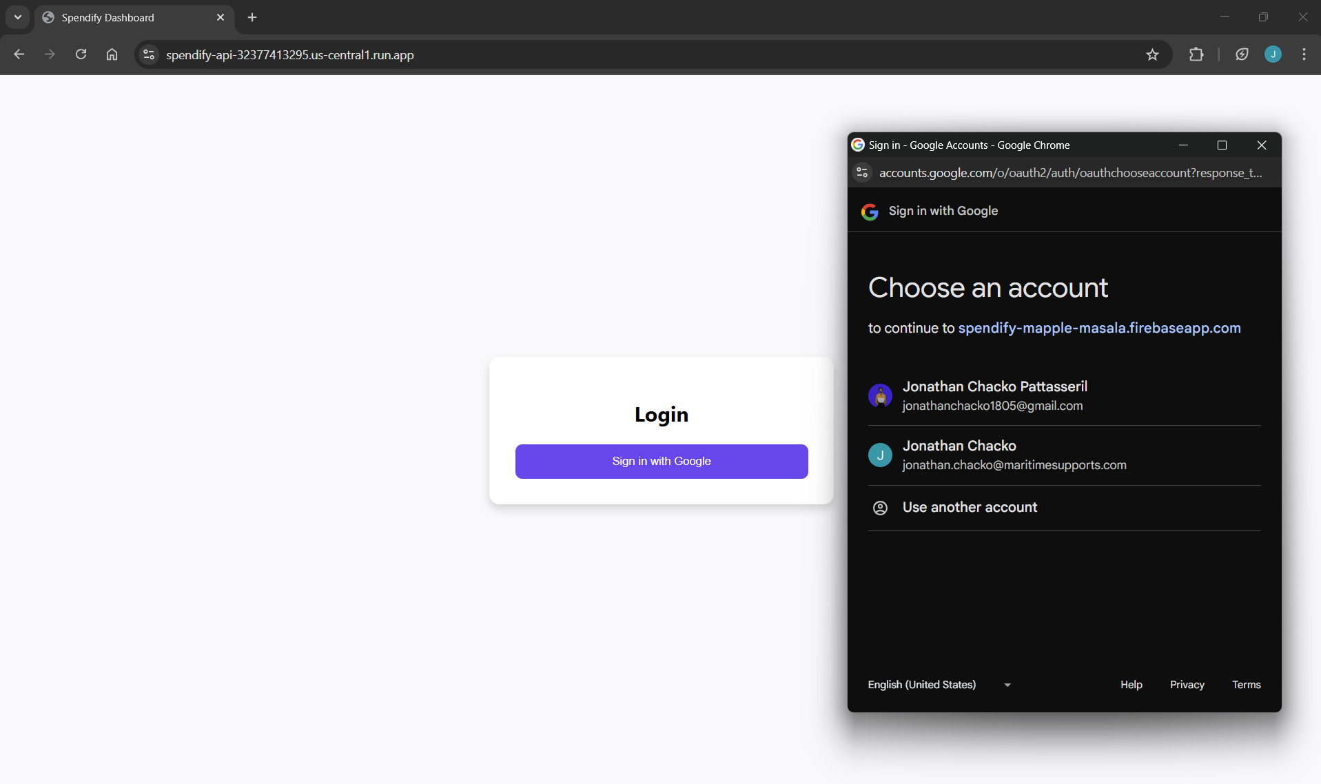
User Dashboard: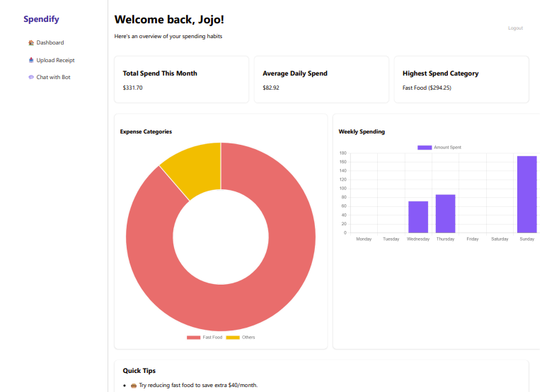
User has Option to Upload Receipt from another Source like this Dashboard: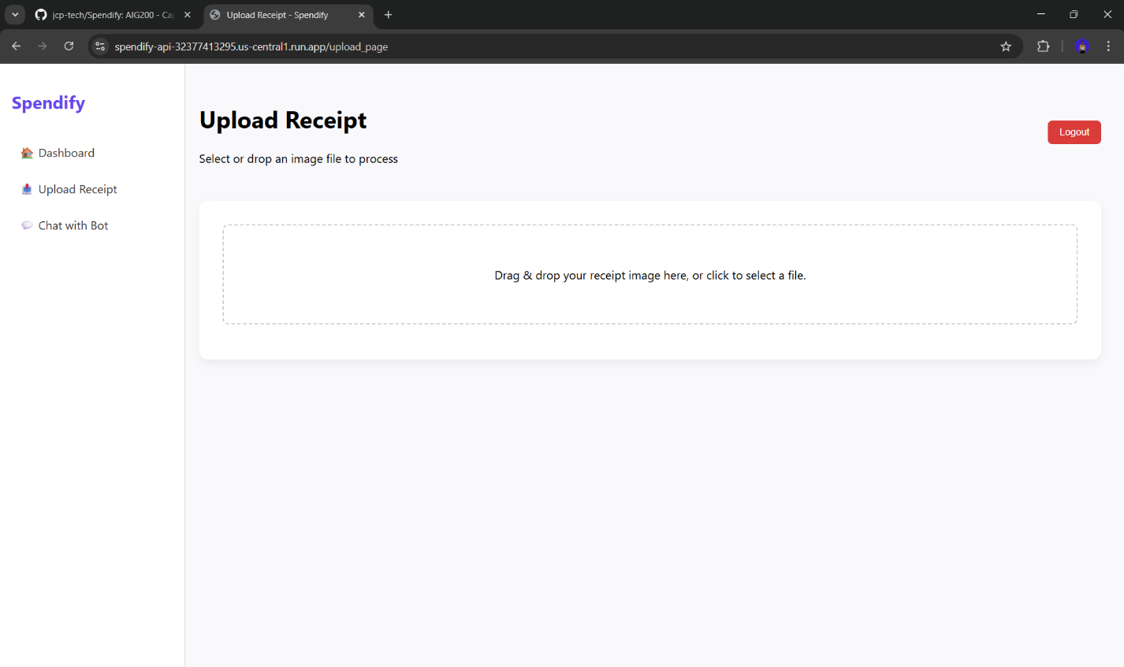

Ethical Considerations
Spendify processes financial documents that may include sensitive personal data. To uphold user privacy, all receipt images and processed data are securely stored in a private Firebase database, with access restricted to authenticated project components. No personal identifiers are logged or shared externally. The system is designed without user profiling or monetization at this stage to avoid misuse. Future expansions will include formal privacy policies and data consent mechanisms to align with ethical AI and data governance standards.

Conclusion & Future Work
Spendify successfully delivers an end-to-end receipt processing pipeline, replacing LLM fragility with robust agent workflows. With deployment in place and real-time Discord integration, the platform lays a strong foundation for production-ready tools.

Next Steps
- Finalize regression model integration
- Complete frontend dashboard features
- Implement real-time expense summaries
- Create a WhatsApp Bot for Spendify
- Demonstrate Implementation in Business System’s like CRM’s
- Add AI chat integration via it’s Multiple Sources (eg: Discord and Dashboard)
- Explore monetization and scalability for productization

References
Discord. (n.d.). https://discord.com/developers/docs/quick-start/getting-started#configuring-your-bot
Flask. (n.d.). https://flask.palletsprojects.com/en/stable/api/
Firebase. (n.d.)
  - Firestore= https://firebase.google.com/docs/firestore/quickstart#python
  - Authentication= https://firebase.google.com/docs/auth/web/google-signin
Google Cloud. (n.d.). Document AI overview. https://cloud.google.com/document-ai/docs/setup
Google Cloud. (n.d.). Agent Builder (ADK) documentation. https://google.github.io/adk-docs/
AI Model Selection:
  - Vertex AI Platform= https://cloud.google.com/vertex-ai/generative-ai/docs/models
  - AI Studio= https://ai.google.dev/gemini-api/docs/models
GitHub. (2025). Spendify project repository. https://github.com/jcp-tech/Spendify

